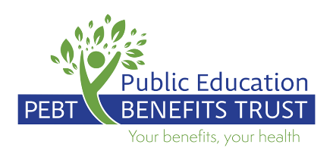

[DATE]

[EMPLOYEE NAME]
[EMPLOYEE ADDRESS]
[EMPLOYEE ADDRESS]
[CITY], [PROVINCE]
[POSTAL CODE]

Dear [EMPLOYEE NAME],
RE: IMPORTANT NOTICE ABOUT YOUR EXTENDED HEALTH AND DENTAL COVERAGE
Currently, premium contributions for extended health (including the Medical Referral Travel Benefit where applicable) and/or dental coverage provided through the Public Education Benefits Trust (PEBT) and administered by Pacific Blue Cross (PBC) are paid for by the long term disability (LTD) Program during the first two years of a Member’s LTD claim.
As you are approaching the two-year milestone of your LTD claim, where the definition of your disability also changes from your own occupation to any occupation, this letter is to advise you that premium contributions paid on your behalf by the PEBT will conclude as of [END DATE]. Should you wish to continue the extended health and/or dental coverage you currently have in place, please contact your benefits administrator at your school district within 31 days of [END DATE] to discuss your options.
Please note, you may be responsible for a portion or all the premium contribution for these benefits should you wish to continue coverage after [END DATE]. If you do not contact your school district benefits administrator this coverage may be terminated, and medical evidence of good health may be required should you wish to re-enroll for coverage in the future.
More information about the PEBT benefits program can be found at www.pebt.ca.

