Salary Mass Update Instructions (PEBT)
File Layout Specifications
The information that is required to process mass salary update file. Complete all Mandatory fields in the required format.
Field Name | Description | Requirement | Format
Policy Number | Policy number | Mandatory | Numbers
ACES Cert Length | Certificate length required for this Policy | Optional | Numbers  Certificate number will fill in leading zeros if Certificate Number does not meet the required length.
Certificate Number | Employee’s PBC Certificate number | Mandatory | Text, provide leading zeroes if applicable
Hours Worked | Hours Worked | Optional | Numbers  If provided must be greater than zero. One decimal place is accepted.
Frequency Worked | Weekly | Mandatory if Hours Worked is provided | Text  Fixed value – must be Weekly. Case insensitive.
Employment Type | - FullTimeSalary  - FullTimeHourly  - PartTimeHourly  - PartTimeSalary  - Retired  - Client  - Casual  - Temporary  - Seasonal  - Contract  - OnLTDClaim  - HourBank | Mandatory if Hours Worked is provided | Text  If provided must be one of the values and format specified in the Description column. Case insensitive.
Income Amount | Salary Amount | Mandatory | Numbers  No dollar signs or commas. Allows up to two decimal places.
Income Frequency | Annual | Mandatory | Text  PEBT - must be Annual and format specified in the Description column.  Case insensitive.
Income Type | Salary | Mandatory | Text  Fixed value – must be Salary. Case insensitive.
Effective Date | Effective date of change | Mandatory | Date  Format must be one of:  - YYYY-MM-DD  - YYYY-MON-DD  - YYYY/MM/DD  - MM/DD/YYYY
First Name | First Name | Optional | Text  Case insensitive.
Last Name | Last Name | Optional | Text  Case insensitive.

File Naming Convention
File name must include policy number and effective date.
The file name IncomeAnnualSalary_Policynumber_<<YYYYMMDDHHMI>>.xlsx
Do not change tab name, column headers or order.
Example: IncomeAnnualSalary_12345_202510011230.xslx
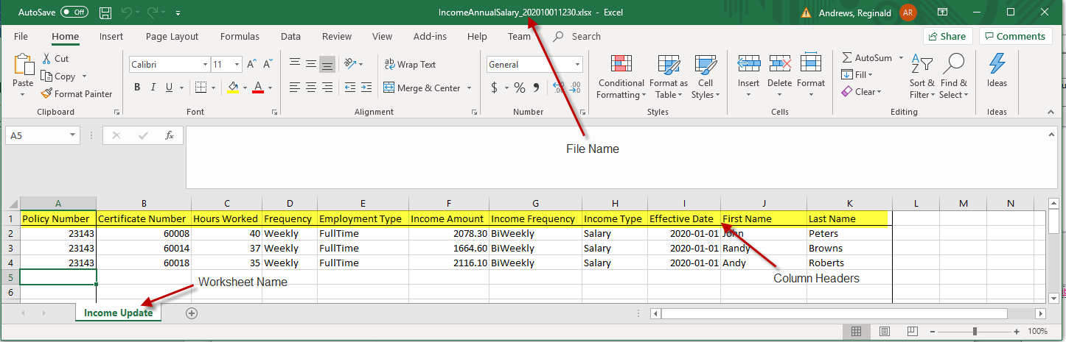
Send completed file securely to PBC Member Administration enrollment@pac.bluecross.ca

